**Indian Trade Analysis and Forecasting**

**Project Report for the month of February**

**Akarsh Somani (162) and Gaurav Misra (172)**

**Current Status-**

Earlier we break timeseries into components like Trend, Seasonality and Randomness.

We tried to forecast using few more techniques like exponential smoothing, Holt-Winters Method and seasonal ARIMA.

**The RMSE are as shown**

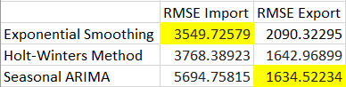

Next, we will look forward to find more insights about the Import and Export.

**Brief Explanation-**

***Exponential Smoothing –***

Forecasts are calculated using weighted averages where the weights decrease exponentially as observations come from further in the past, the smallest weights are associated with the oldest observations:

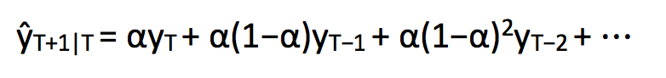

where 0≤ α ≤1 is the **smoothing** parameter.

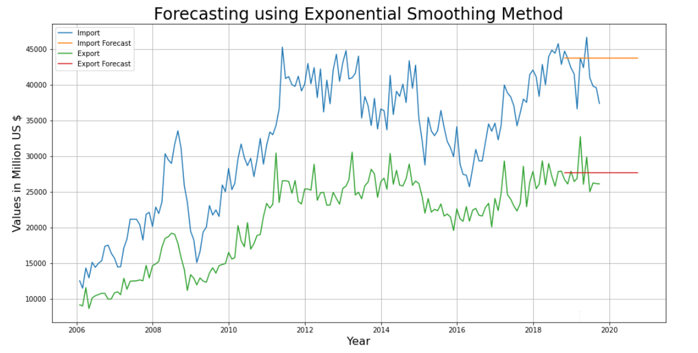

***Holt-Winters –***

The Holt-Winters seasonal method comprises the forecast equation and three smoothing equations — one for the level ℓt, one for trend bt and one for the seasonal component denoted by st, with smoothing parameters α, β and γ.

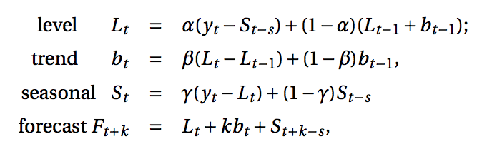

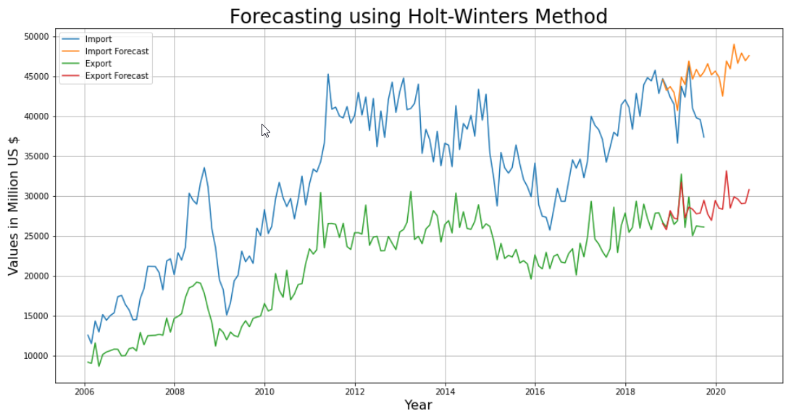

***Seasonal ARIMA -***

ARIMA with added factor of seasonality

